DUSEMOND STUDY PROGRAMMES MANUAL HANDLING RISK ASSESSMENT
Company name: Dusemond | Assessment carried out by: Robin Fry
Date of assessment: 1st February 2024 | Date of next review: January 2025

Manual handling operation | Is there a significant risk of injury? | Can the operation be avoided or mechanised? | Can the operation be completed within the HSE manual handling guidelines? See Figure 1 and Table 1 below. | Is a detailed risk assessment required?
Lifting and moving office equipment and stationery | Yes | No | Yes | No
Lifting and carrying suitcases | Yes | No | Yes | No
Setting up of computers, printers and photocopiers | No | No | Yes | No
Lifting and carrying sports equipment | Yes | No | Yes | No
Packing and unpacking boxes when setting up centres | Yes | No | Yes | No
Carrying and lifting books | No | No | Yes | No
Rearranging classroom and office furniture | Yes | No | Yes | No
Replacing water in watercoolers | No | No | Yes | No

Is the load greater than shown in Figure 1 when held in the position indicated? | If YES, a detailed assessment must be carried out.
Can the load be held against the body? | If NO, a detailed assessment must be carried out.
Can the person walk normally when carrying the load? | If NO, a detailed assessment must be carried out.
Is the load difficult to grasp or handle? | If YES, a detailed assessment must be carried out.
Does the operation require the hands to be held below knuckle height? | If YES, a detailed assessment must be carried out – if weight exceeds that in Figure 1.
Does the operation require the hands to be held above elbow height? | If YES, a detailed assessment must be carried out – if the weight exceeds that in Figure 1.
Will the load obstruct the person’s view? | If YES, a detailed assessment must be carried out.
Will the load be carried more than 10m? | If YES, a detailed assessment must be carried out.
Is the person a new or expectant mother? | If YES, a detailed assessment must be carried out.
Is twisting of the torso required? | If YES, a detailed assessment must be carried out.
Does the person have a disability, recent injury or significant health problem? | If YES, a detailed assessment must be carried out.
MANUAL HANDLING ASSESSMENT GUIDELINES (indg143 (hse.gov.uk)

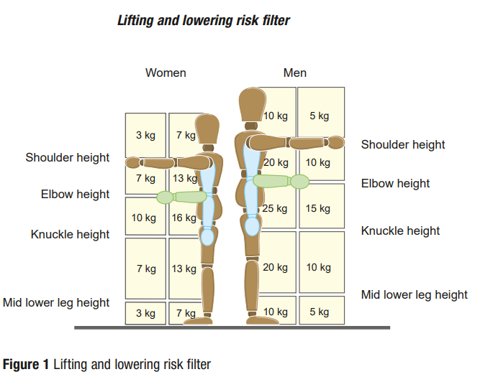
Table 1

